RNN for NLP

*Recurrent neural nets* (RNNs) enable neural networks to remember the past words within a sentence.

1. ***Word order***—here are two statements that don’t mean the same thing:
2. The dog chased the cat.

The cat chased the dog.

1. ***Word proximity***—here “shone” refers to the word “hull” at the other end of the sentence:
2. The ship's hull, despite years at sea, millions of tons of cargo, and two mid-sea collisions, shone like new.

*The stolen car sped into the arena.*

*The clown car sped into the arena.*

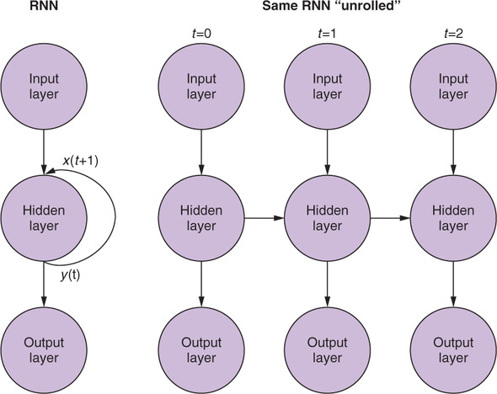

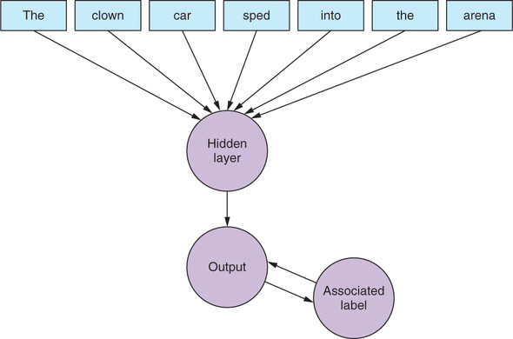

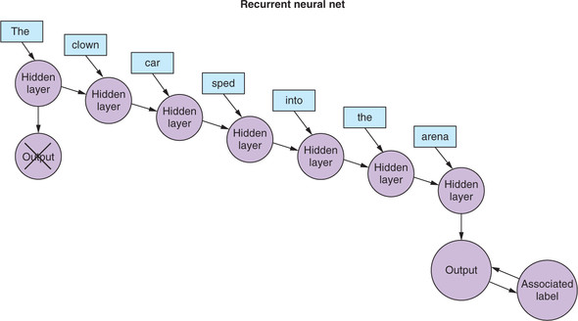

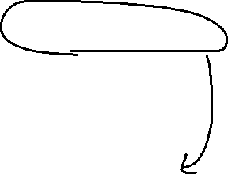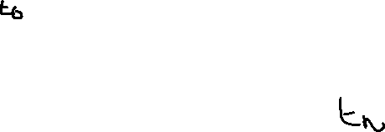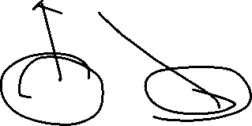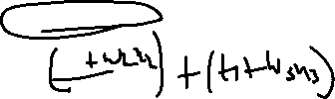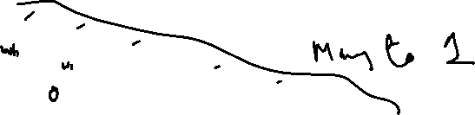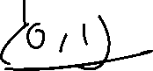

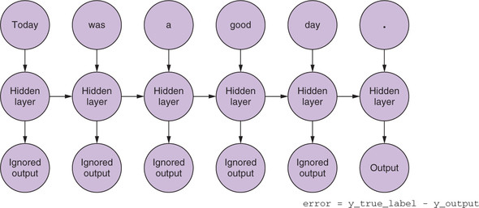

Many to 1

* Break each data sample into tokens.
* Pass each token into a feedforward net.
* Pass the output of each time step to the input of the same layer alongside the input from the next time step.
* Collect the output of the last time step and compare it to the label.
* Backpropagate the error through the whole graph, all the way back to the first input at time step 0

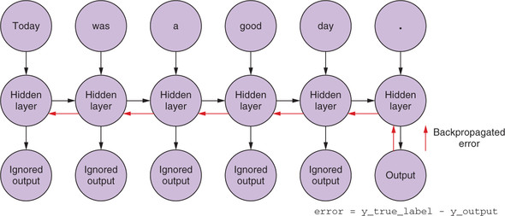

Many to many

